|  |
| --- |
|  |
| Designing for  Modern UI  Module 1: The New Windows UI Design Solution |
|  |

|  |
| --- |
|  |

Windows, Bing, PowerPoint, Internet Explorer, Visual Studio, WebMatrix, DreamSpark, and Silverlight are either registered trademarks or trademarks of Microsoft Corporation in the United States and/or other countries. Other product and company names mentioned herein may be the trademarks of their respective owners.

The example companies, organizations, products, domain names, e-mail addresses, logos, people, places, and events depicted herein are fictitious. No association with any real company, organization, product, domain name, e-mail address, logo, person, place, or event is intended or should be inferred.

The information contained in this tutorial is provided without any express, statutory, or implied warranties. Neither the authors, Microsoft Corporation, nor its resellers or distributors will be held liable for any damages caused or alleged to be caused either directly or indirectly by this tutorial.

Created for Microsoft by Avlade: www.Avlade.com

Copyright 2012 by Microsoft Corporation.

­Table of Contents

Overview 4

Learning objective 4

Starting up 4

Checking for applications that are already installed 6

Setting up photos 7

Concepts behind new Windows UI style applications 7

To Do: Investigating a new Windows UI style app 10

What Windows 8 has to offer 11

The components for a Windows 8 application 11

Canvas 12

Charms 12

Search charm 13

Share charm 14

Devices charm 15

Settings charm 15

Touch language 16

App bar 16

The Windows 8 views 18

Landscape 18

Portrait 19

Snap view 20

Watch the video: Overview of new Windows UI components 21

Snap view 21

Summary 21

Self-study 22

Questions 22

Additional resources 22

Answers 23

## Overview

Windows 8 marks the next step in the evolution of the modern design style, referred to as new Windows UI style design. Through the bold use of color, typography, and motion, new Windows UI style design is a common design aesthetic that brings a fresh new approach to user experience. In this module, you will discover the design principles behind new Windows UI and be provided with insights for how to apply these principles in applications that you build.

New Windows UI design is based on the principles of classic Swiss graphic design which favors text as the primary form of navigation. The interface is focused on clean typography and less on UI chrome, such as buttons, borders, rules and other graphics.

From conception to final application, new Windows UI style apps represent not only modern day interfaces, but also a satisfying user experience that allows users to remain focused and confident when using new Windows UI design style applications.

## Learning objective

In this module, you’ll discover the background behind new Windows UI and how New Windows UI style design relates to established design principles. Participants also discover how new Windows UI design has been adapted to offer a consistent user experience using various new Windows UI components such as:

* Charms for Search, Share, Settings, and Devices
* Touch language for interactions
* App bar for commanding

## Starting up

In order to follow this module you must have Windows 8 installed. You can get the latest information about Windows 8 and the consumer preview download at <http://windows.microsoft.com/en-US/windows-8/consumer-preview>.

For this module, you will need to install two applications; Photos, and PuzzleTouch. Follow these steps to locate the necessary applications and install them on your system.

1. In order to locate these apps, click on the Store icon in Start. The Store location appears.

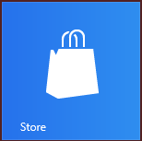

*Click on the Store tile to launch the Windows 8 Store app.*

1. Press the Winkey + C, or swipe from the right side of the screen to expose the Search charm.
2. Click once on the Search charm and type **photo** into the Search text field. The Photos application appears in the result beneath the text field. Click on it to select it. The search results appear.

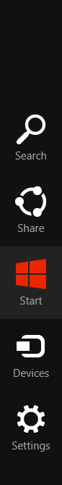 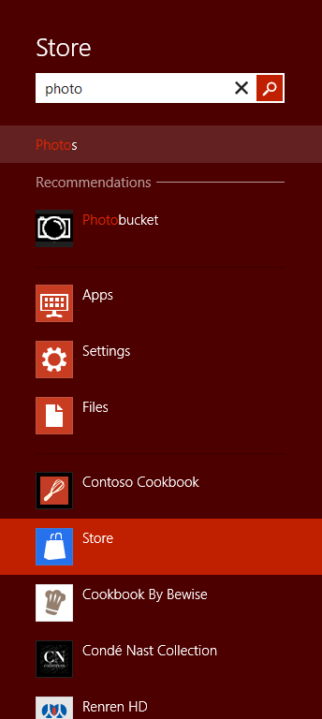

*Click on the Search charm, and   
then type* ***photo****.*

1. Click once on Photos in the results field; the application description page appears. If the message appears that you own this app, you can go to step 6. Otherwise press Install. A notification appears in the upper right indicating that your application is installing.
2. Press the Winkey + C, or swipe from the right side of the screen to expose the Search charm again.
3. Type **Puzzle** in the Search text field. If store is not selected as the search target, click on it in the list of applications that appear below the Search text field.

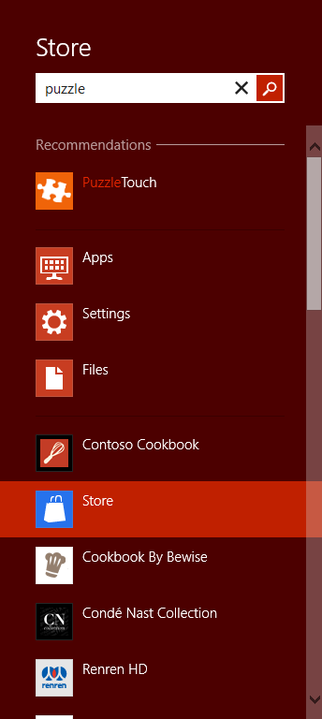

*Locate the PuzzleTouch app.*

1. Select PuzzleTouch from the results, and if it is not yet installed click install. The PuzzleTouch application is installed.
2. Press the Winkey + C, or swipe from the right to display the charms and click Start to return to the Start screen, or press the Winkey.

## Checking for applications that are already installed

You can also check to see if you have an application installed before going to the Store. Follow these steps to see if you have the default application Finance installed. If not, you can go through the steps to install that application as well.

1. Press the Winkey + C, or swipe from the right to display the charms and click on the Search charm.
2. If Apps is not selected, click on it now and start typing **finance**. If the Finance app is installed, it will appear in the results on the left.
3. If the Finance app is not installed, click on Store under the Search text field, and then select the magnifying glass located on the right side of the Search text field. The results for the search in the Store appear on the left side.
4. Click on the Finance app and then click on Install.
5. Press the Winkey to return to Start.

## Setting up photos

If you have not installed any images on to your machine, you can load images into the Pictures folder.

1. In Start, click on the Desktop tile, or press Winkey + D.
2. Using a network, or USB device, select some images and load them into your Libraries > Pictures folder.
3. Press the Winkey to return to Start and click on Photos. You now have images to use later in this module.

## Concepts behind new Windows UI style applications

New Windows UI is the code name for Microsoft’s design language. It’s rooted in modern, Swiss design which emerged from Switzerland in the 1550s. Swiss design has an emphasis on reduction, cleanliness, readability, simple and beautiful visuals; it also includes influences from other movements, such as the Bauhaus school in Germany, and the International Typographic Style.

The International Typographic Style emphasizes cleanliness, readability and objectivity. Hallmarks of the style are asymmetric layouts, use of a grid, sans-serif typefaces, and flush-left, ragged-right text. The style is also associated with a preference for photography in place of illustrations or drawings.

The international Typographic Style marked by:

* The use of a mathematical grid to provide an overall orderly and unified structure
* Sans serif typefaces (especially Helvetica, introduced in 1961) in a flush-left and ragged-right format
* Black and white photography in place of drawn illustration. The overall impression was simple and rational, tightly structured and serious, clear and objective, and harmonious.

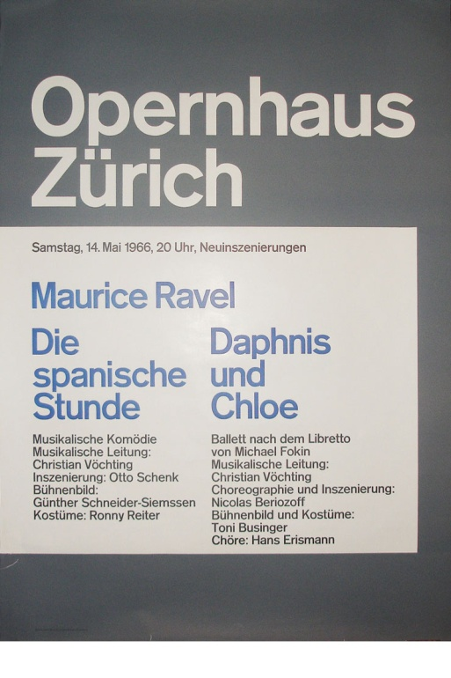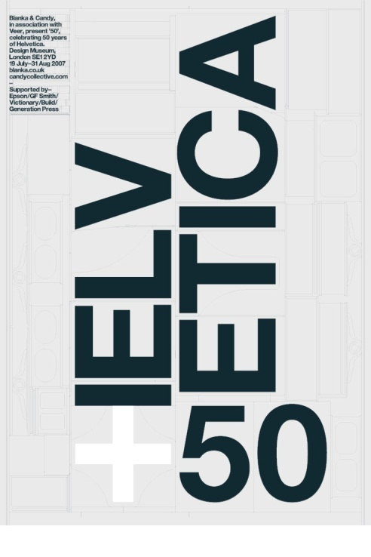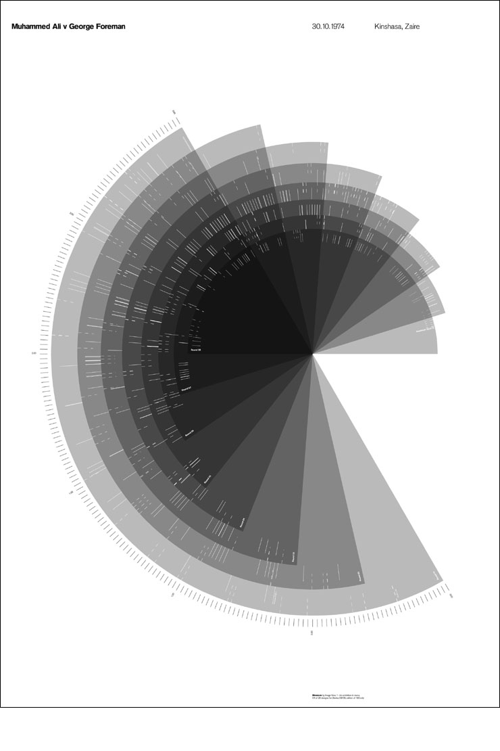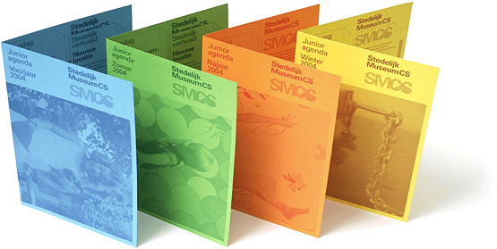When discussing modern design, it is important to mention the Bauhaus school, which operated in Germany from 1919 to 1933, and combined crafts and the fine arts. At that time the German term Bauhaus, literally meant "house of construction.” During the Bauhaus movement, designers of all materials focused on a fierce reduction of unnecessary elements, as you also see in new Windows UI style apps. Designs that were influenced by the Bauhaus movement included printed, mechanical, and furniture design to name a few. Now in modern design, the Bauhaus movement influences interactive design for screen presentation of information as well.

Examples of Swiss design.

You can see the heavy use of text and grids in new Windows UI design, and this follows through to applications that are created to work on the Windows 8 platform.

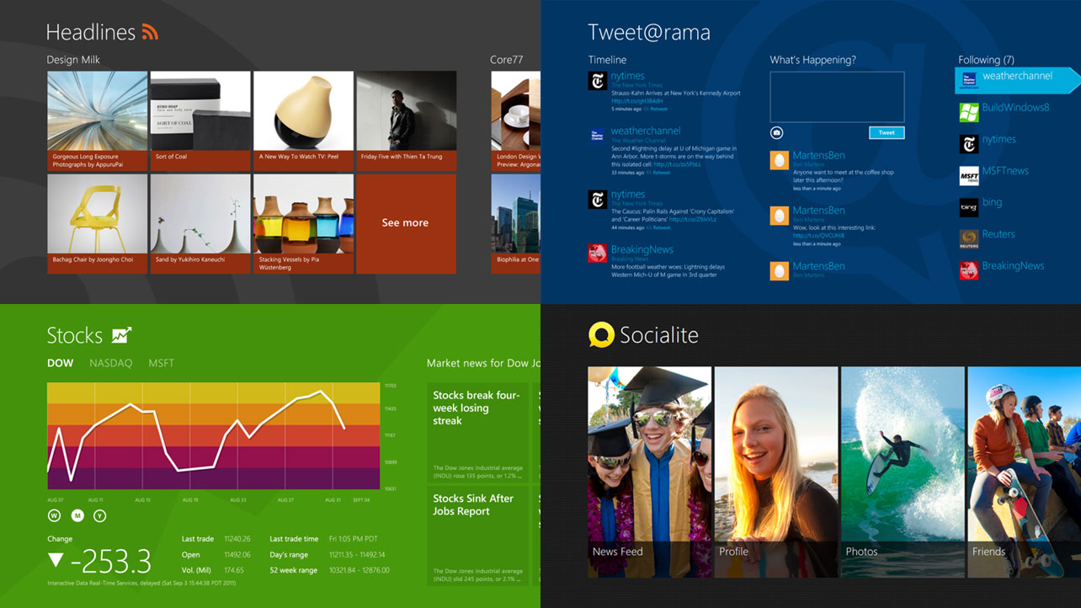

Type is emphasized in new Windows UI applications.

New Windows UI is also designed on the concept of travel signage. Typically travel signs, seen in subways, airports, on the highway, and other locations, provide organized and clear messaging. They display only the necessary elements so that travelers can focus on the information that is important and not be distracted.



Travel signage had a large influence on new Windows UI design.

In this module, you will discover how the Windows 8 platform helps new Windows UI style apps to focus on essence and make the apps excellently crafted by combining the influences of Swiss design, the Bauhaus movement, and travel signage. You will also discover how the Windows 8 platform allows designers to keep the user focused on what is important, and keep distractions to a minimum, by taking advantage of the Windows 8 components.

### To Do: Investigating a new Windows UI style app

In this section, you will investigate an existing app to see how text and imagery is applied in a new Windows UI style app.

1. From Start, scroll to the right to select recently added applications. If you just installed Photos, PuzzleTouch, or Finance, they will appear to the right of the initial Start screen. Keep in mind that when you activate a mouse you can scroll by using the scrollbar at the bottom of the screen, or you can:
2. Click on the Finance Tile, the application launches.

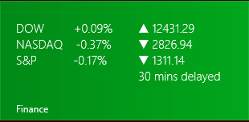

Click on a tile to launch an app.

The Finance app has a unique still, but you can still see the strong use of text and imagery used in the layout of the initial screen.



*The Finance app uses text and imagery in a structured clear manner.*

1. Select other applications that you already have installed to investigate the strong sense of organization and use of text.
2. When finished, press the Win key to return to Start.

## What Windows 8 has to offer

Windows 8 is different than any other operating system offered by Microsoft. Windows 8 runs consistently on multiple devices, such as tablets, desktops, and other touch devices. It also has several views to consider, including Portrait and Snap, which are discussed later in this series. This opens up the opportunity for designers of Windows 8 applications to have a user-base unlike they have had with any other version of Windows. This opportunity requires the designer to have knowledge of the Windows 8 platform so they can build successful, focused, applications.

Windows 8 helps designers build better applications by providing users a consistent UI model. This consistent UI model allows designers to focus their application on what it does best, keeping the application clean and distraction-free.

Listed below are some of the main components in the Windows 8 platform that help keep a new Windows UI style application focused on creating the best user experience:

* Canvas
* Charms for Search, Share, Settings, and Devices
* Touch language for interactions
* App bar for commanding

Read the following section to gain a better understanding of how these components fit into the overall Windows 8 platform, and how they affect your new Windows UI design applications.

## The components for a Windows 8 application

In this section, you are introduced to the components of the Windows 8 platform, starting with the main component, the canvas. These components are discussed in more detail throughout the series. You have an opportunity to follow step-by-instructions to use charms, but all the charms will be covered later in this series in more detail.

## Canvas

The canvas is the surface of a device, in which users interact with the OS and the applications. In Windows 8, users are able to complete core scenarios, such as launching applications, searching, sharing and navigating the content of their system just by using the canvas. In the perfect Windows 8 environment, a user directly manipulates the content on the app's canvas, rather than adding commands that act on the content. In Windows 8, two applications can be displayed in the canvas, one in Snap view, and the other in the Main window. Throughout this series, you will see that the primary running application is referred to as the Main Application.

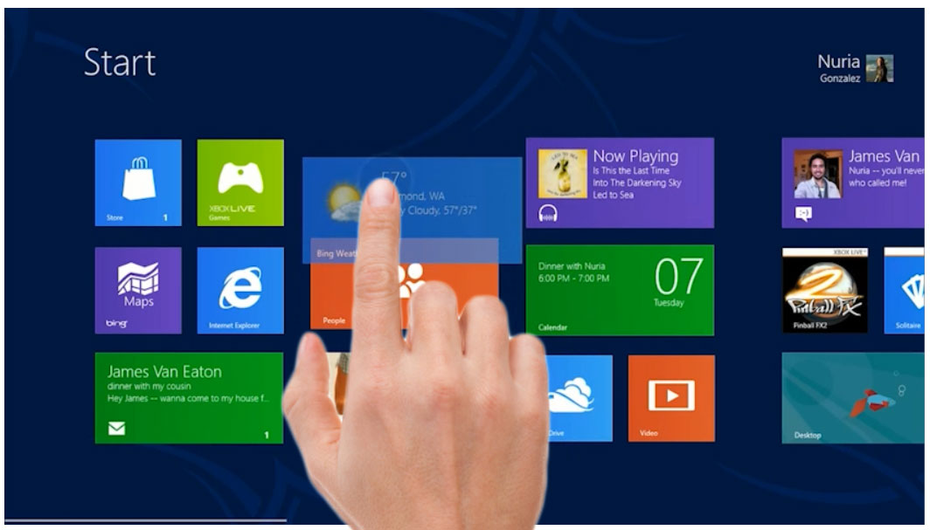

The canvas includes everything on the surface of a device.

## Charms

Charms allow users to use common commands across multiple applications to have a consistent UI Model. Charms used in the Windows 8 platform include Search, Share, Devices, such as print, video, and tap to send. Charms are accessed by swiping from the right side, by positioning the mouse in the lower-right side of the canvas, or by pressing Winkey + C.

The charms are one of the key components that allow designers to reduce of unnecessary elements. This is because charms are in integral part of the over Windows 8 UI, and include one location where users can change their settings, search and share. Charms allow the designers to build their applications without concerning themselves with integrating those elements into their own application.

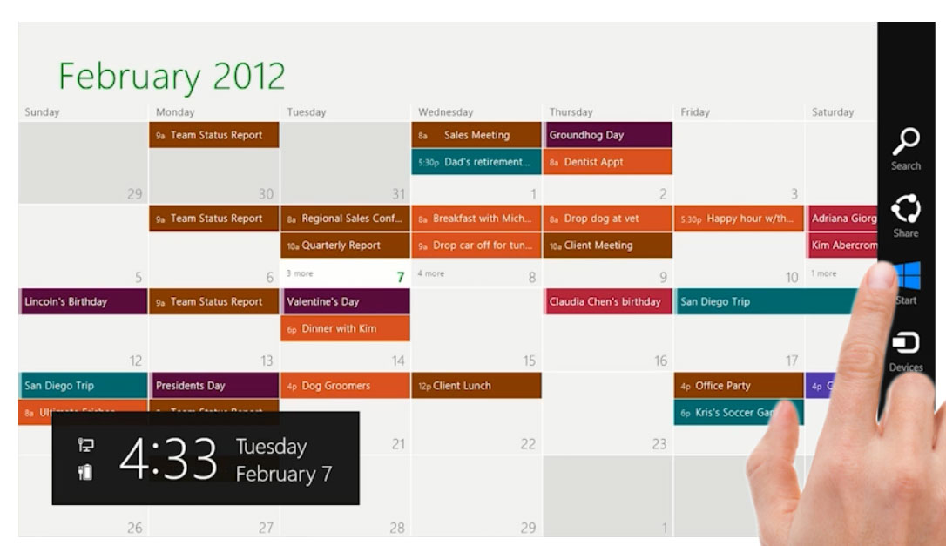

Swipe or select with the mouse in the lower-right to see the charms.

In order for your application to use charms a developer must activate the related contracts. Even though this activation is done in the development stage, designers need to plan how the use of contracts changes the architecture of their application. For instance, a new Windows UI application should not have a search control on the canvas, but the designer still needs to create some sort of experience for search results.

Keep in mind that this part of the module is to introduce you to some of the capabilities of charms. You will find out more about charms in Module 8: “Winning as One: Using Charms Contracts.”

## Search charm

The Search charm allows users to search the main application that is in use, but also allows users to quickly search through any app's content from anywhere in the system, including other apps that are not in the Main view. You saw this demonstrated earlier in this module when you searched your system for the Finance app, and then searched the Store. Follow these steps to test the Search Charm.

1. With the Start menu visible press Winkey + C to open the charms and click on the Search Charm.
2. Because you began from Start, Apps is selected as the search target. Type **puzzle**, and PuzzleTouch appears in the results.
3. Now click on Internet Explorer in the app listing under the Search text field. Now you get the results for puzzle in the browser window.
4. Press the Winkey + C to return to the Start.

NOTE that you are not quitting each app. It is not necessary, as each app goes inactive when not being used. You will find out later in this module how to put away apps, and cycle through them.

## Share charm

The Share charm lets your users share content from your app with other people or apps, and receives shared content. Just like other charms, the Share charm is activated in the development stage of building a Windows 8 app; but as a designer, you need to determine what should be shared. Do you want your app to be a share target, where other applications can send their content to your app? Or, do you want to be a Share source, where you can be the creator of the source that is to be shared.

Before following these steps, make sure that you have followed the steps in the beginning of this module and installed the Photo, and PuzzleTouch apps from the Store.

1. Launch the Photos app. Since you installed images into your Pictures folder, you see images in the Pictures library category when the Photos app is launched.

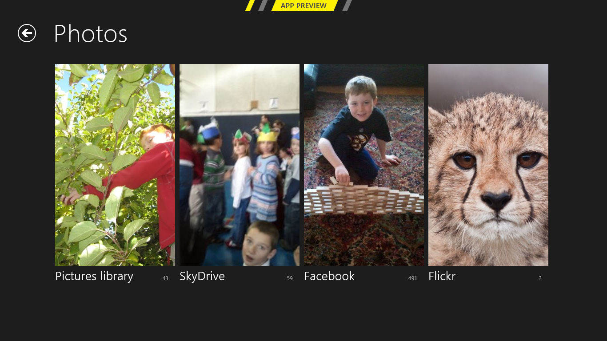

*The Photos app.*

1. Click once on Pictures library, and then click on a photo that you wish to convert into a puzzle.
2. Press the Winkey + C, or swipe form the right side to show the charms and click on Share. Notice that Photos is a share source and can share with other applications, like Mail and PuzzleTouch.
3. Click on PuzzleTouch; you are presented with options about what you want to do with this image in the PuzzleTouch application. Select Intermediate (12 pieces, with rotation). The application begins processing your image right away.
4. When the progress bar and options disappear, swipe to show the charms again, click on Search and then on Apps.
5. Type **puzzle** into the Search text field, and then select PuzzleTouch from the results. The PuzzleTouch application launches.
6. Scroll to the right to locate the intermediate puzzles and click on the puzzle you just created. Because PuzzleTouch is set up to be a share target, you were able to share directly with the application.

You can finish the puzzle if you wish, or press the Winkey, or swipe from the right to show the charms and click on Start, to return to Start.

## Devices charm

The Devices charm lets your users enjoy audio, video, or images streamed from your app to other devices in their home network. It can also be used to set up a second screen or projector. If you click on the Devices charm, you may only see the Second screen at this time, but eventually other devices that relate to video display and printers will be available.

## Settings charm

The Settings charm helps keep applications focused, as it consolidates all app settings under one location. Keeping settings in one location also builds a great user experience as users will have one place to look when locating application preferences and global settings for all their apps.

You can experiment by launching various apps and then clicking on Settings. You see that apps allow global setting changes to occur in this Setting window. Keep in mind that the look and feel of this Settings view is an experience that a designer is responsible for creating.

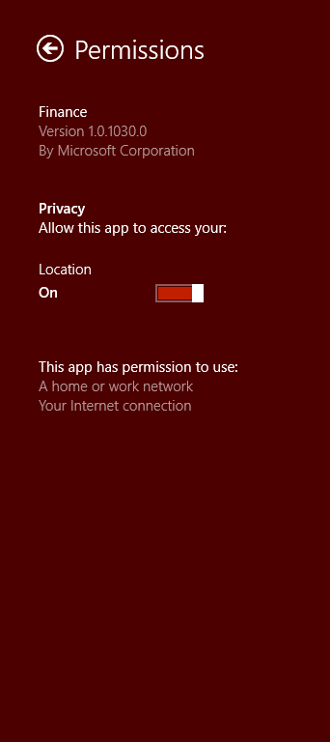 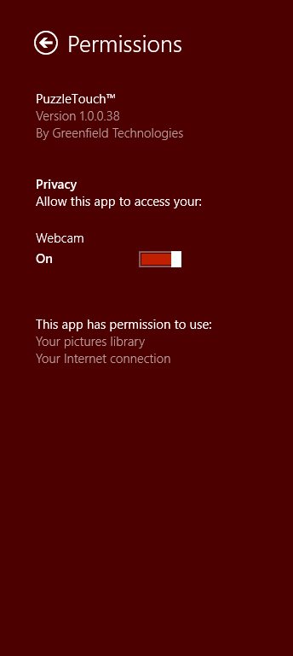 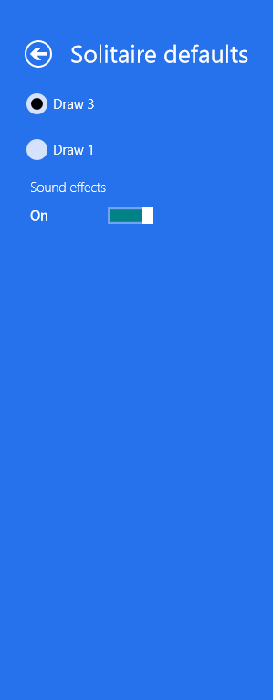

The settings for the Finance, PuzzleTouch, and Solitaire apps.

## Touch language

If you have a touch device, you may have effortlessly navigated the system and different apps without any complicated issues. This is because the touch language is an integral part of a the Windows 8 platform and a new Windows UI style app. Windows 8 provides a concise set of [touch interactions](http://msdn.microsoft.com/en-us/library/windows/apps/hh465415.aspx#touch_language) that is used consistently throughout the system. By applying this language consistently to your app, it will feel familiar to users, making it easier to learn and use, and therefore increasing their confidence. You will discover how the touch language works in Windows 8 in Module 7: “Being Fast and Fluid, and Authentically Digital.”

If you don’t have a touch device, you most likely have been navigating effortlessly as well. This is because the mouse and keyboard have are fully supported in Windows 8. They are functionally consistent with touch, yet provide the unique and distinctive interaction experiences you and your users are familiar with.

## App bar

The app bar helps you design an app that follows the new Windows UI style concept of doing more with less. The App bar allows you to conceal commands, or features, until they are needed. This allows your users to focus on the task at hand and not commands that don’t apply to their present scenario.

The user accesses the app bar by swiping the bottom edge of the screen and can interact with the content to make app bars disappear. App bars can also be used to show commands or options that are specific to the user's context, such as photo selection or drawing mode.

If you have a command that is necessary for a user to complete a workflow (such as buying a product), place those commands on the canvas instead of in app bars.

1. On your Windows 8 device, select the Photos app from Start, and then click on one of your Photo libraries.
2. Swipe up from the bottom to make the app bar visible. Note the options that are available for the user.

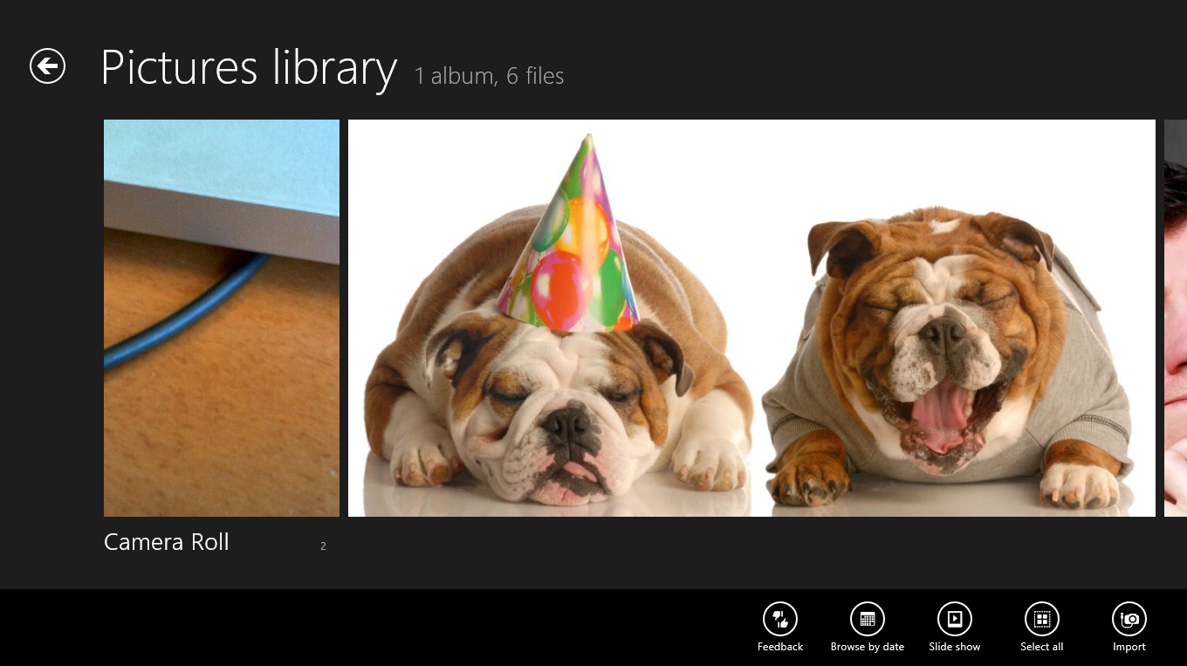

The app bar exposes features for the user when needed.

1. Swipe down on an image to select one image.
2. Swipe up from the bottom to expose the app bar again. You can see that now that you have a selection, a different set of options (or features) are available to you. These new options are contextual and based upon your selection.
3. Select the Start charm or press the Win key to return to the Start menu.

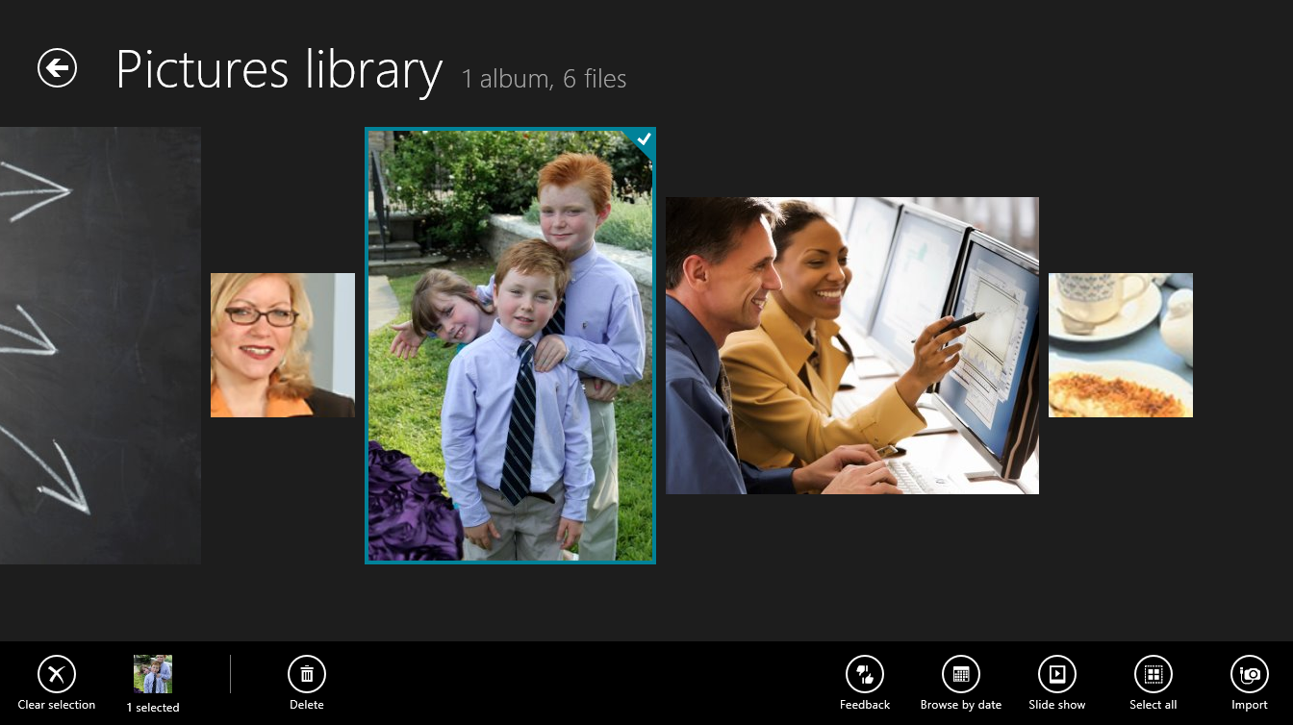

The app bar changes when an image is selected.

You will find out more about designing appropriate features for your app and where to position those features in Module 5: “Organizing Features To Fit The Scenario”.

## The Windows 8 views

A new Windows UI style app contains new views that a UX designer might not have had to consider in the past. You have the main landscape view, snap view, and portrait view. As designers, you also have to work with different resolutions and screen sizes. These views are discussed in more detail in Module 10: “Designing for Multiple Screens and Resolutions.”

## Landscape

The landscape view will be your most popular view, as many desktop units and laptops will be running Windows 8. You should design to this view and build alternate versions for portrait if you wish to accommodate that view as well.

You can also decide to keep your app in landscape view even when the screen has been rotated although that can lead to user frustration; users may suspect it is a failure in your app. Solitaire is an example of an app that “prefers” landscape, as it might be difficult to rearrange the stacks of cards in portrait.

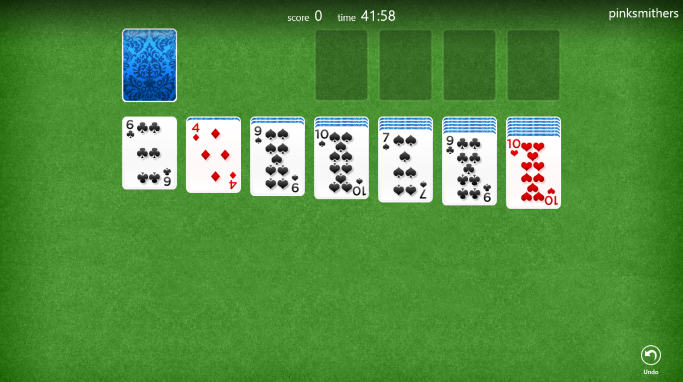

Solitaire stays in landscape view when the screen is rotated.

## Portrait

Depending whether you have an accelerometer in your device, you may not be able to view the portrait view. In Module 10, you will have an opportunity to test a simulator that will allow you to test your app in landscape or portrait view without actually rotating your screen.

Keep in mind that portrait is a view that should be accommodated for in the design process. As a designer, you can also determine that you always want your app to be viewed in landscape view.

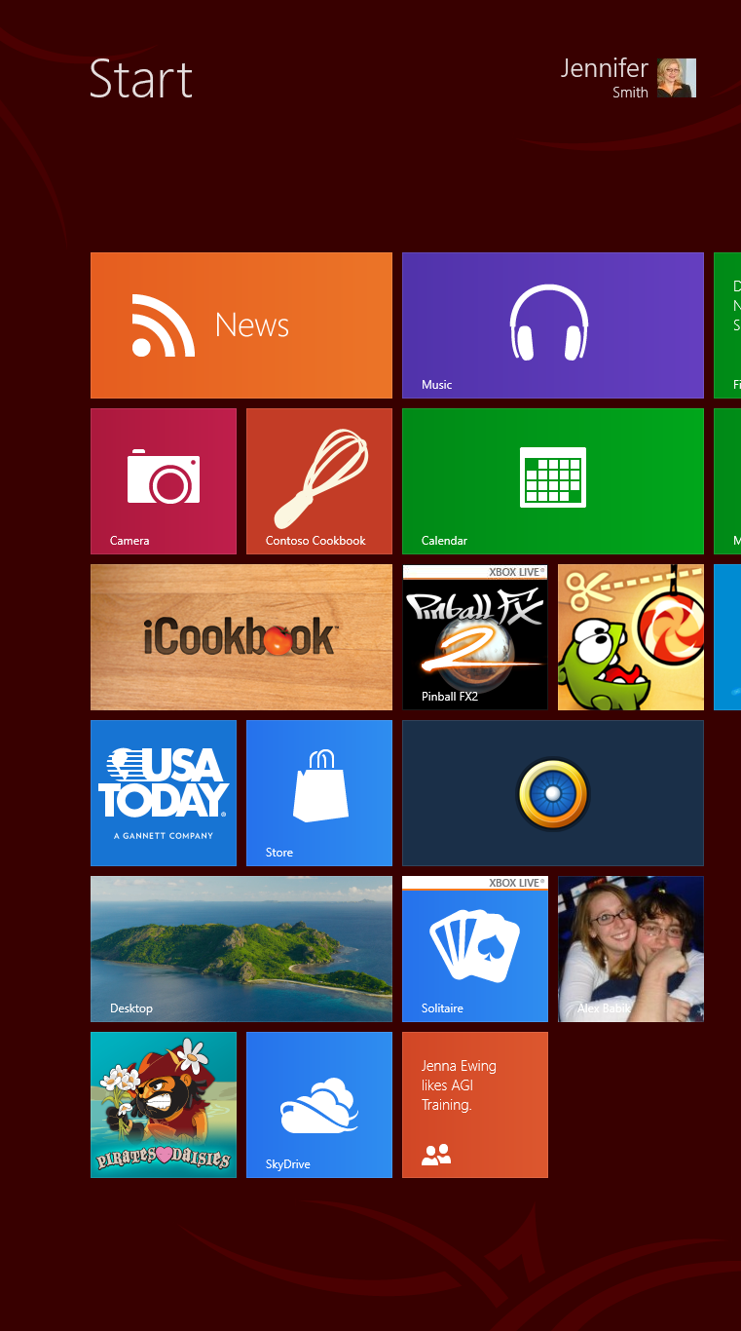

The Start in portrait view.

## Snap view

The snap view is about keeping your applications open and in front of the user as much as possible. The snap view allows two applications to be displayed simultaneously; one in the main view, and the other in the snap view.

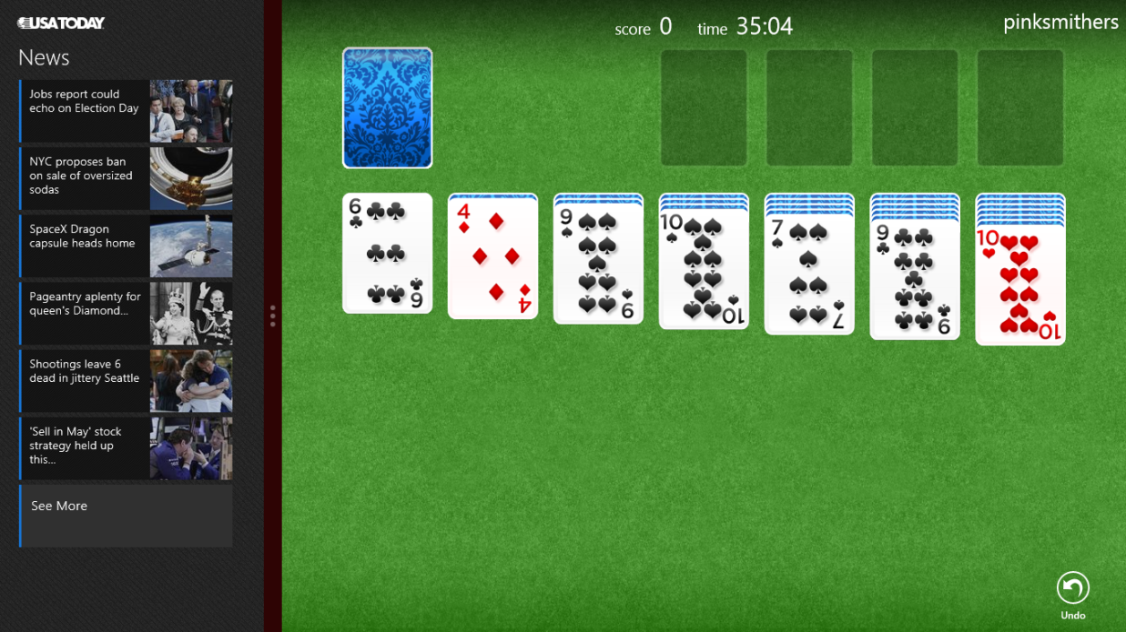

The News app in the snap view. Solitaire in the Main app view.

The snap view is a required view, as all applications are snappable, whether a designer has accommodated for that view or not. As it is part of the Windows 8 platform, it is just expected to work by the users.

The snap view is another view that should be tailored to create a successful user experience for the user. Keep in mind that this is not a gadget; this is your fully functioning app in a much more narrow view. At this time be aware that this view is something that you will have to put some thought into, but specifications and implementing this view occur in Module 10: “Designing for Multiple Screens and Resolutions.”

## Watch the video: Overview of new Windows UI components

In this video, a demo of new Windows UI Design is provided. Definitions of components are provided as demonstration is in process. Interaction, animation, and touch are introduced as the participants see how new Windows UI works on a touch device.

## Snap view

The snap view is beneficial as it allows users to keep an application open and in front of them while they perform other tasks. The snap view allows two applications to be displayed simultaneously; one in the main view, and the other in the snap view.

## Summary

In this module, you learned about the foundation and influences behind new Windows UI style apps. You also had the opportunity to experiment with some of the important components, such as charms, that help designers to reduce the amount of unnecessary elements in their app designs.

This module also introduced you to different views that you will see as you work with more applications on the Windows 8 platform.

## Self-study

On your own, navigate the apps on your Windows 8 system to discover which ones effectively use charms, especially share, and settings. Using charms should not be an afterthought, when creating your apps, keep them in mind from your app’s conception through to completion.

## Questions

1. What are the three major influences behind new Windows UI apps?
2. Why are charms critical to the design of a new Windows UI style app?
3. What are three views that you should be concerned with when designing an app for Windows 8?

## Additional resources

The following resources can help you understand the broader principles of good design.

* **Ten principles of good design**

<http://www.vitsoe.com/en/gb/about/dieterrams/gooddesign>

* **Book: Foundation of Swiss Design**

Swiss Graphic Design, by Richard Hollis, ISBN: 0-300-10676-9

* **Resources from Microsoft on build new Windows UI style apps**

<http://msdn.microsoft.com/library/windows/apps/>

## Answers

1. There are many different influences behind new Windows UI Style apps, four are listed below:

* Swiss design
* International Typographic Style
* Bauhaus school
* Travel signage

1. Three views that you will want to consider in your designs are Landscape, Portrait, and Snap.
2. The use of charms is critical to the design of a new Windows UI style app because their use allows a designer to reduce the amount of content in their app. Charms also provide a consistent location for all users to find settings, sharing, and searching capabilities.